Xiaoxu Na

Lab – Transcription Bind Site

Q1

* 1. There are 5.

5 position frequency matrices from 5 sources:

JASPAR_2014: 1

JASPAR_CORE: 1

jaspar2016: 1

jaspar2018: 1

ScerTF: 1

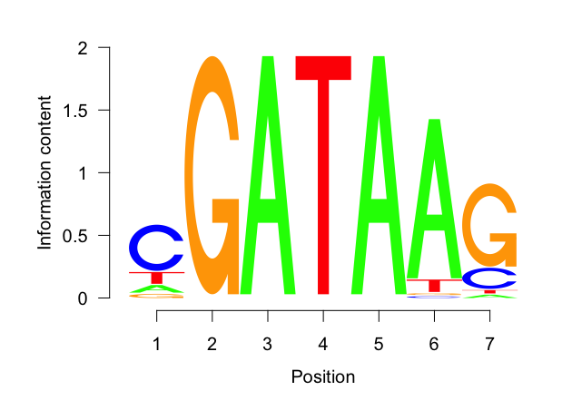

* 1. CGATAAG
  2. GATAA

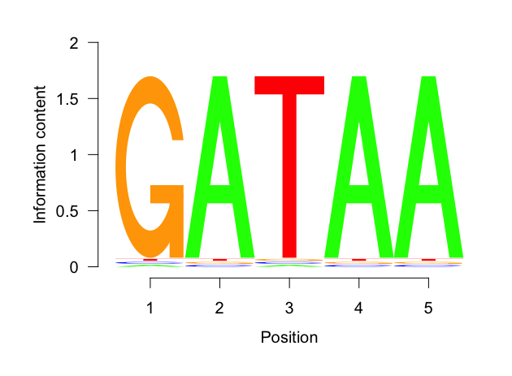

Q2

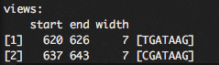

Q3

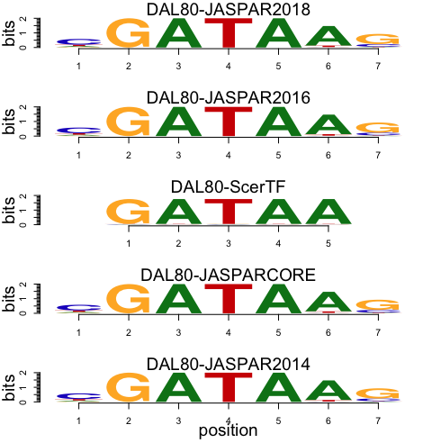

Most are similar, but DAL80-ScerTF has only 5 positions, comparing with the rest 4 all have 7 positions.